Funding Request
Engineering Leadership Council
College of Engineering
University of Nevada, Reno
Please use this template for a Funding Request to the Engineering Leadership Council. Please do not alter or remove the paragraphs already written on the template, the font, or the margin size. Only one grade per funding request. Please submit as a PDF to the Funding Request page, http://www.nevadaelc.com/funding-request.html

Engineering Student Organization Name: Engineering Club
Date of application submission: 10/30/19
Grade (only one): Grade 2
Total Cost of Event: $1915.41
Students in Attendance: 12
If funds within grade 1 are requested for more than 10 people, names and roles during
travel must be included on the excel sheet on the Travel info page.
Proposal Summary:
This is where a club would explain what the items would be used for. i.e. the name of a conference/competition, a project the parts will be assembled into, a volunteering event that “x” people will attend. This is simply an example of random items. NOTE! This funding application includes items that may be used for separate grades i.e. grade 1 travel, grade 2 competition parts, grade 4 events. Items in different grades must be submitted into separate funding application documents.
Line Item Explanation:
Line Item 1:
¼” bolts for assembly of steel bridge
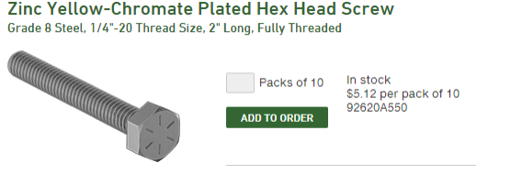

Line Item 2:
Mouse trap car kit kids use to build and learn about potential energy versus kinetic energy
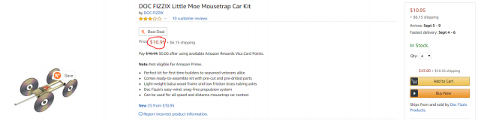

Line Item 3:
Shipping for line item 2
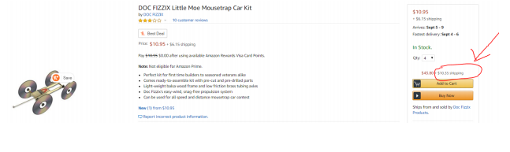

Line Item 4:
Paper towels for general cleaning at monthly waffles event
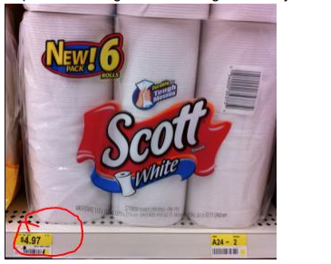

Line Item 5:
Hotel for 6 nights for 12 people
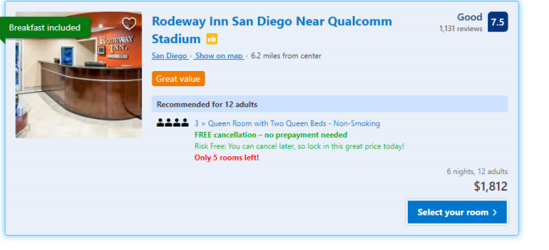

Line item 6:
0.1uF Capacitors for electric furnace controller circuit
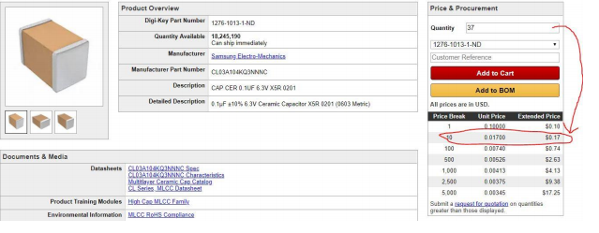

Line Item 7:
Rocket engine for testing prototype rocket
